**Reports Review and Hotfix mail creation**

Review Extent report from below path

\\10.103.3.178\Mahesh440Share\ExtentReports

Select the folder based on Scripts running date in the format MMddYYYY 01252023

Based on version product open folders

Module wise reports have been Generated.

Green color indicates Passed test scripts and red will indicates failed test scripts

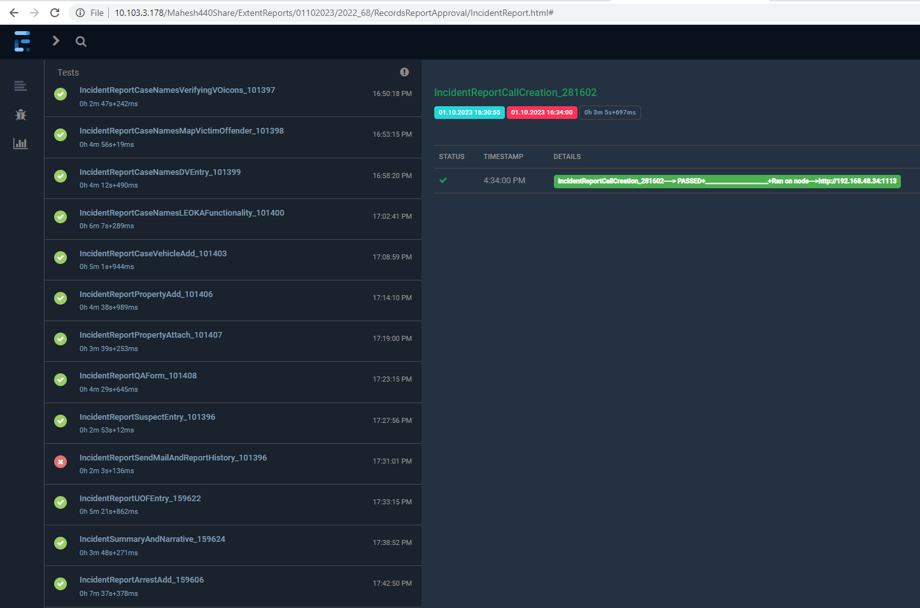

Click on failed test case and review the error message and screenshots.

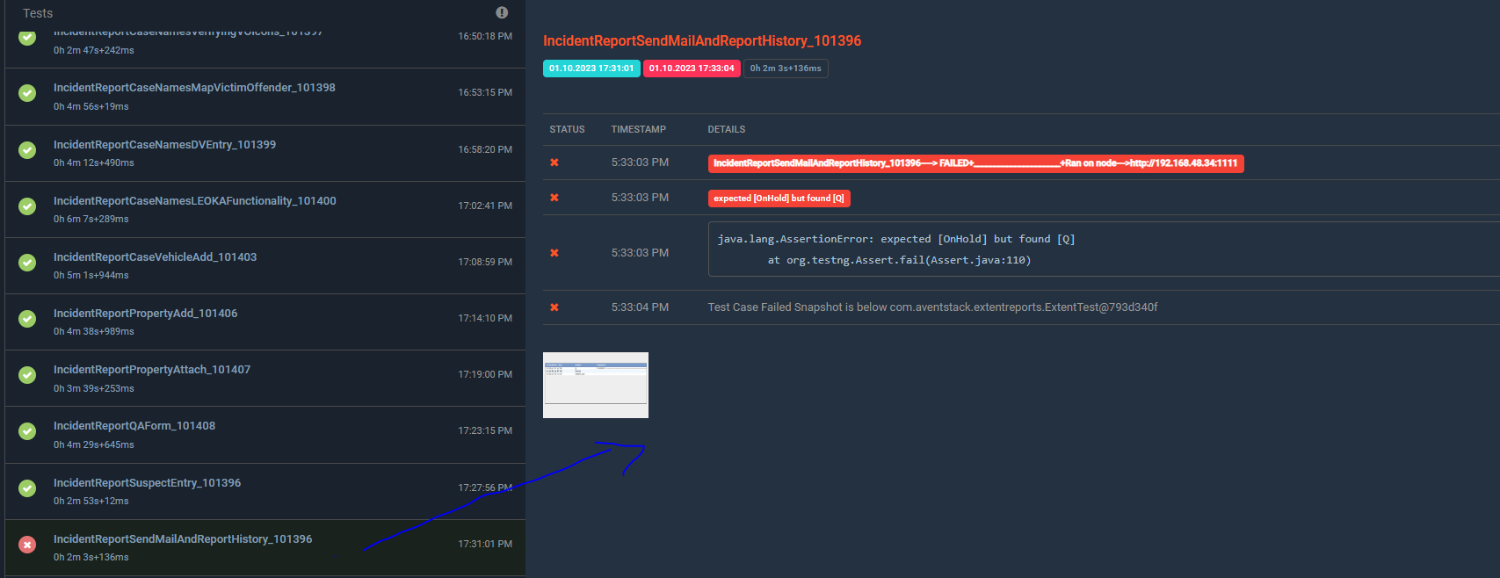

Copy failed test case name and then search in Eclipse scripts file.



Manually executes steps of test scripts verify issue able to reproduce.

If yes, add to issues document.

Check all the scenarios. Review all the extent report failed test cases and do manual approach. If issue replicates all issues in doc

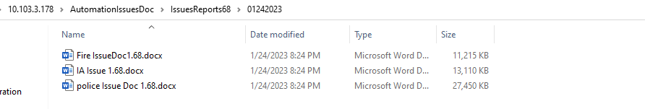

Collect all the issues and send report to respective team.

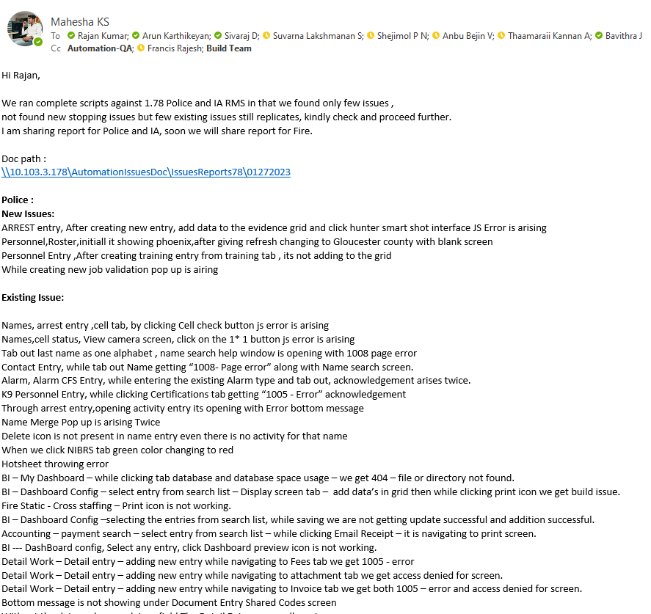

Thank you.